**Cognizant_Digital Nurture 4.0_Deep Skilling**

**Module 10 – Single Page Application framework – React**

**9.** **ES6 Features with React: Cricket App**

**ListofPlayers.js**

import React from 'react';

const ListofPlayers = () => {

  const players = [

    { name: 'Virat', score: 85 },

    { name: 'Rohit', score: 95 },

    { name: 'Dhoni', score: 45 },

    { name: 'Pant', score: 60 },

    { name: 'Rahul', score: 30 },

    { name: 'Jadeja', score: 75 },

    { name: 'Ashwin', score: 55 },

    { name: 'Bumrah', score: 90 },

    { name: 'Gill', score: 20 },

    { name: 'Shami', score: 80 },

    { name: 'Kohli', score: 40 },

  ];

  const below70 = players.filter(player => player.score < 70);

  return (

    <div>

      <h2>All Players:</h2>

      {players.map((player, index) => (

        <p key={index}>{player.name} - {player.score}</p>

      ))}

      <h2>Players with Score Below 70:</h2>

      {below70.map((player, index) => (

        <p key={index}>{player.name} - {player.score}</p>

      ))}

    </div>

  );

};

export default ListofPlayers;

**IndianPlayers.js**

import React from 'react';

const IndianPlayers = () => {

  const players = ['Virat', 'Rohit', 'Dhoni', 'Pant', 'Rahul', 'Jadeja', 'Ashwin', 'Bumrah', 'Gill', 'Shami', 'Kohli'];

  const oddPlayers = players.filter((_, index) => index % 2 === 0);

  const evenPlayers = players.filter((_, index) => index % 2 !== 0);

  const T20players = ['Surya', 'Hardik', 'Chahal'];

  const RanjiTrophyplayers = ['Pujara', 'Karun', 'Vihari'];

  const mergedPlayers = [...T20players, ...RanjiTrophyplayers];

  return (

    <div>

      <h2>Odd Team Players:</h2>

      {oddPlayers.map((name, index) => <p key={index}>{name}</p>)}

      <h2>Even Team Players:</h2>

      {evenPlayers.map((name, index) => <p key={index}>{name}</p>)}

      <h2>Merged T20 + Ranji Trophy Players:</h2>

      {mergedPlayers.map((name, index) => <p key={index}>{name}</p>)}

    </div>

  );

};

export default IndianPlayers;

**App.js**

// src/App.js

import React from 'react';

import ListofPlayers from './ListofPlayers';

import IndianPlayers from './IndianPlayers';

function App() {

  const flag = false;

  return (

    <div className="App">

      <h1>Cricket App</h1>

      {flag ? <ListofPlayers /> : <IndianPlayers />}

    </div>

  );

}

export default App;

**Output:**

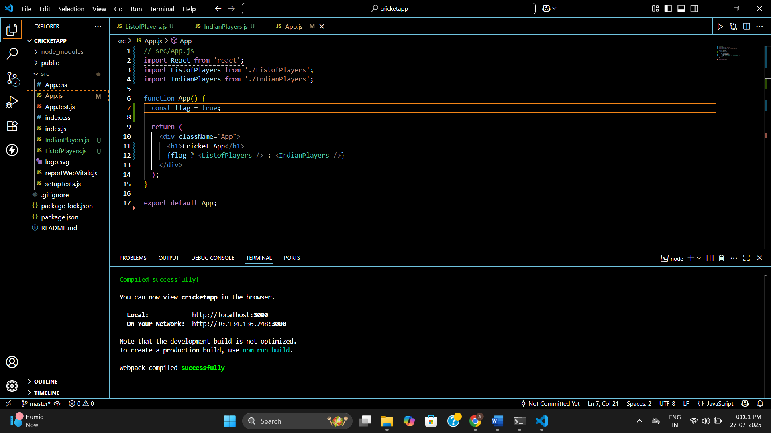

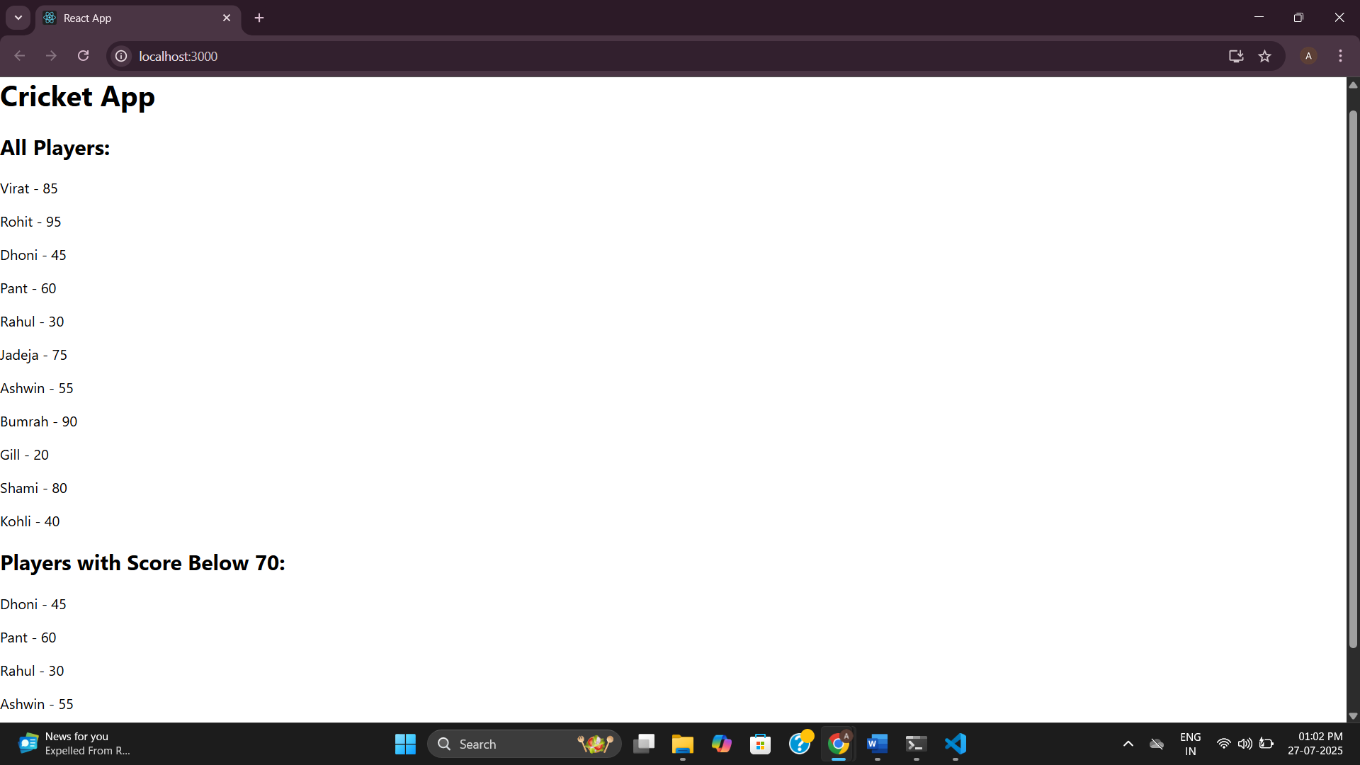

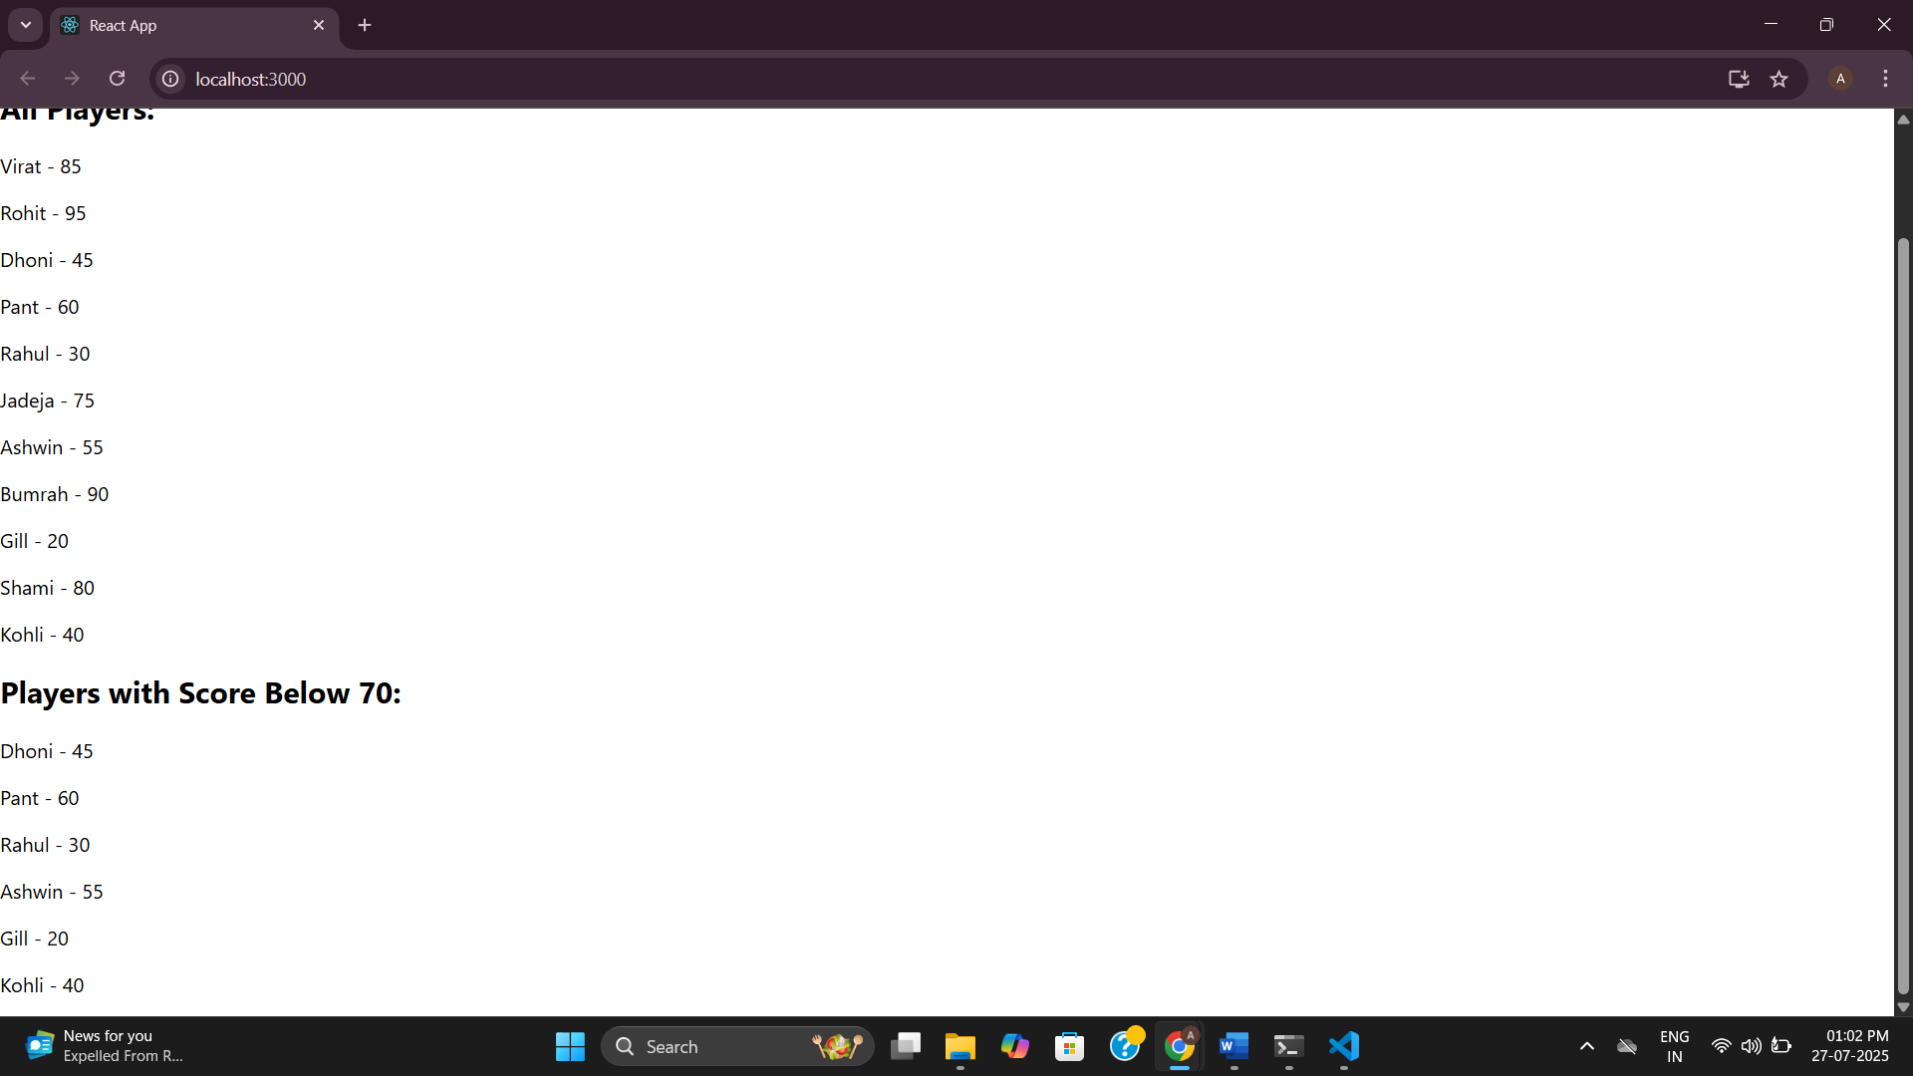

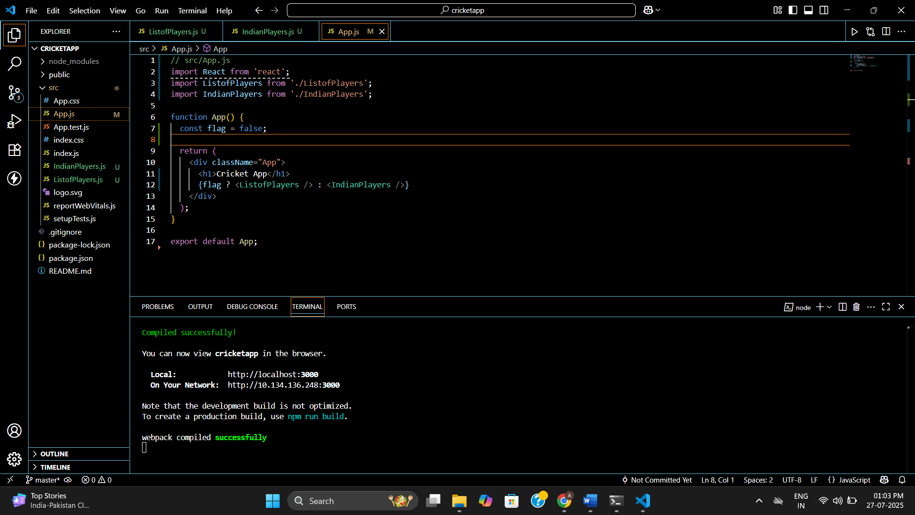

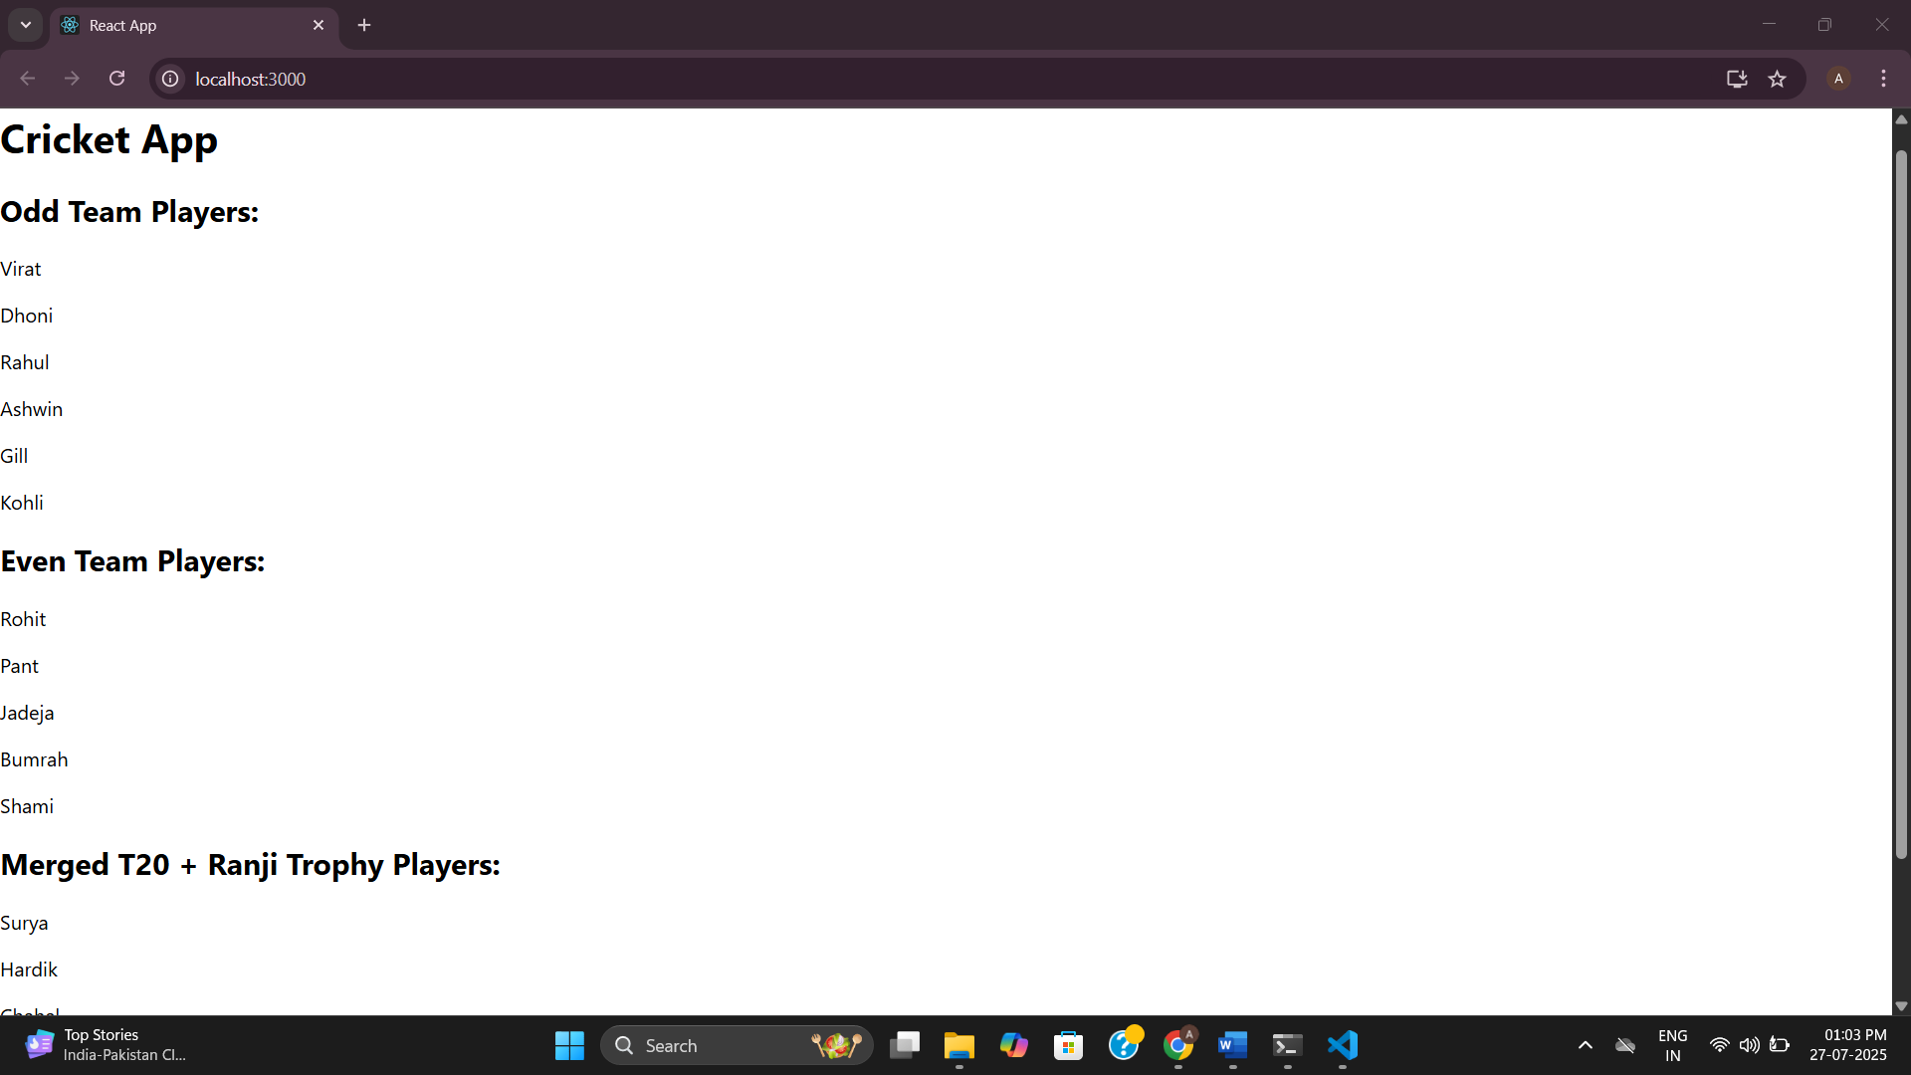

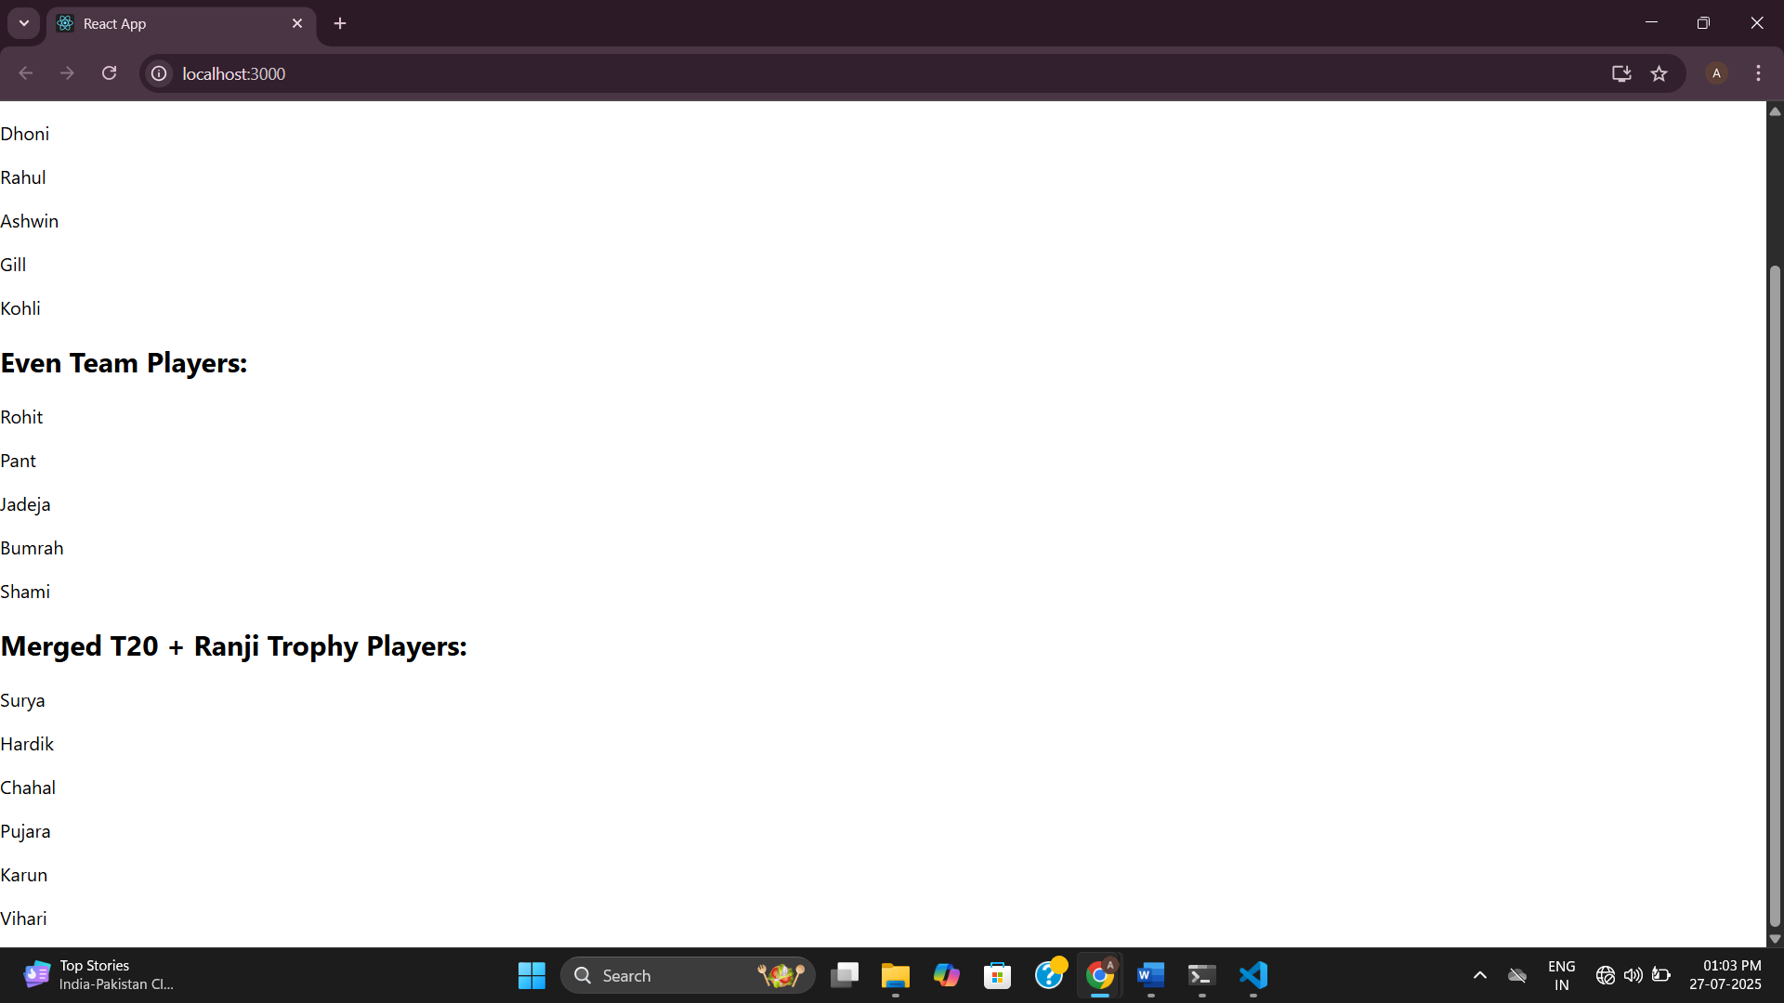

**10.** **JSX-Based Office Rental App**

**App.js**

import React from 'react';

function App() {

const heading = <h1 style={{ textAlign: 'center' }}>Office Space Rental App</h1>;

const imageURL = "https://via.placeholder.com/300x200";

const image = <img src={imageURL} alt="Office Space" style={{ display: 'block', margin: '0 auto' }} />;

const office = {

name: "TechSpace Pvt Ltd",

rent: 55000,

address: "Plot 23, Tech Park, Bangalore"

};

const offices = [

{ name: "WorkNest", rent: 75000, address: "MG Road, Mumbai" },

{ name: "StartupHub", rent: 50000, address: "Sector 62, Noida" },

{ name: "CodeBase", rent: 62000, address: "Hitech City, Hyderabad" }

];

const getRentStyle = (rent) => {

return {

color: rent < 60000 ? 'red' : 'green',

fontWeight: 'bold'

};

};

return (

<div>

{heading}

{image}

<h2>Featured Office:</h2>

<p><strong>Name:</strong> {office.name}</p>

<p><strong>Rent:</strong> <span style={getRentStyle(office.rent)}>{office.rent}</span></p>

<p><strong>Address:</strong> {office.address}</p>

<h2>Other Available Offices:</h2>

{offices.map((item, index) => (

<div key={index}>

<p><strong>Name:</strong> {item.name}</p>

<p><strong>Rent:</strong> <span style={getRentStyle(item.rent)}>{item.rent}</span></p>

<p><strong>Address:</strong> {item.address}</p>

<hr />

</div>

))}

</div>

);

}

export default App;

**Output:**

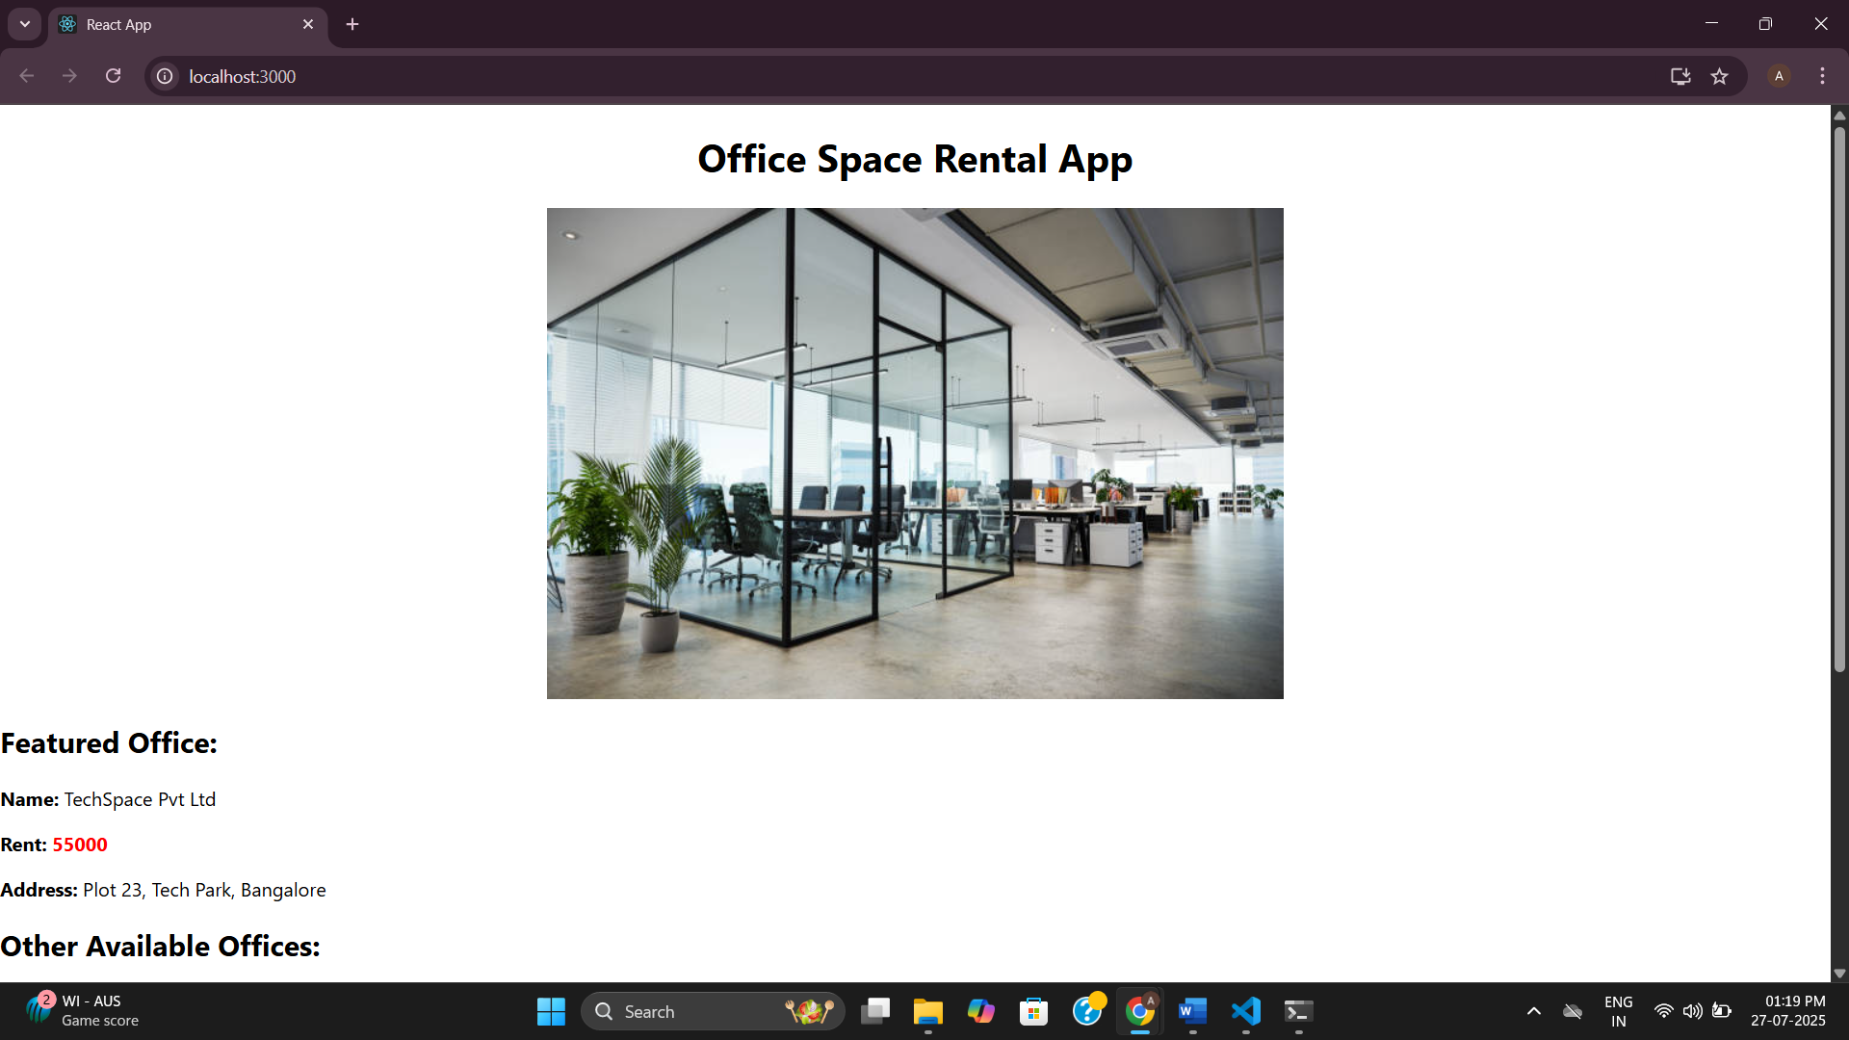

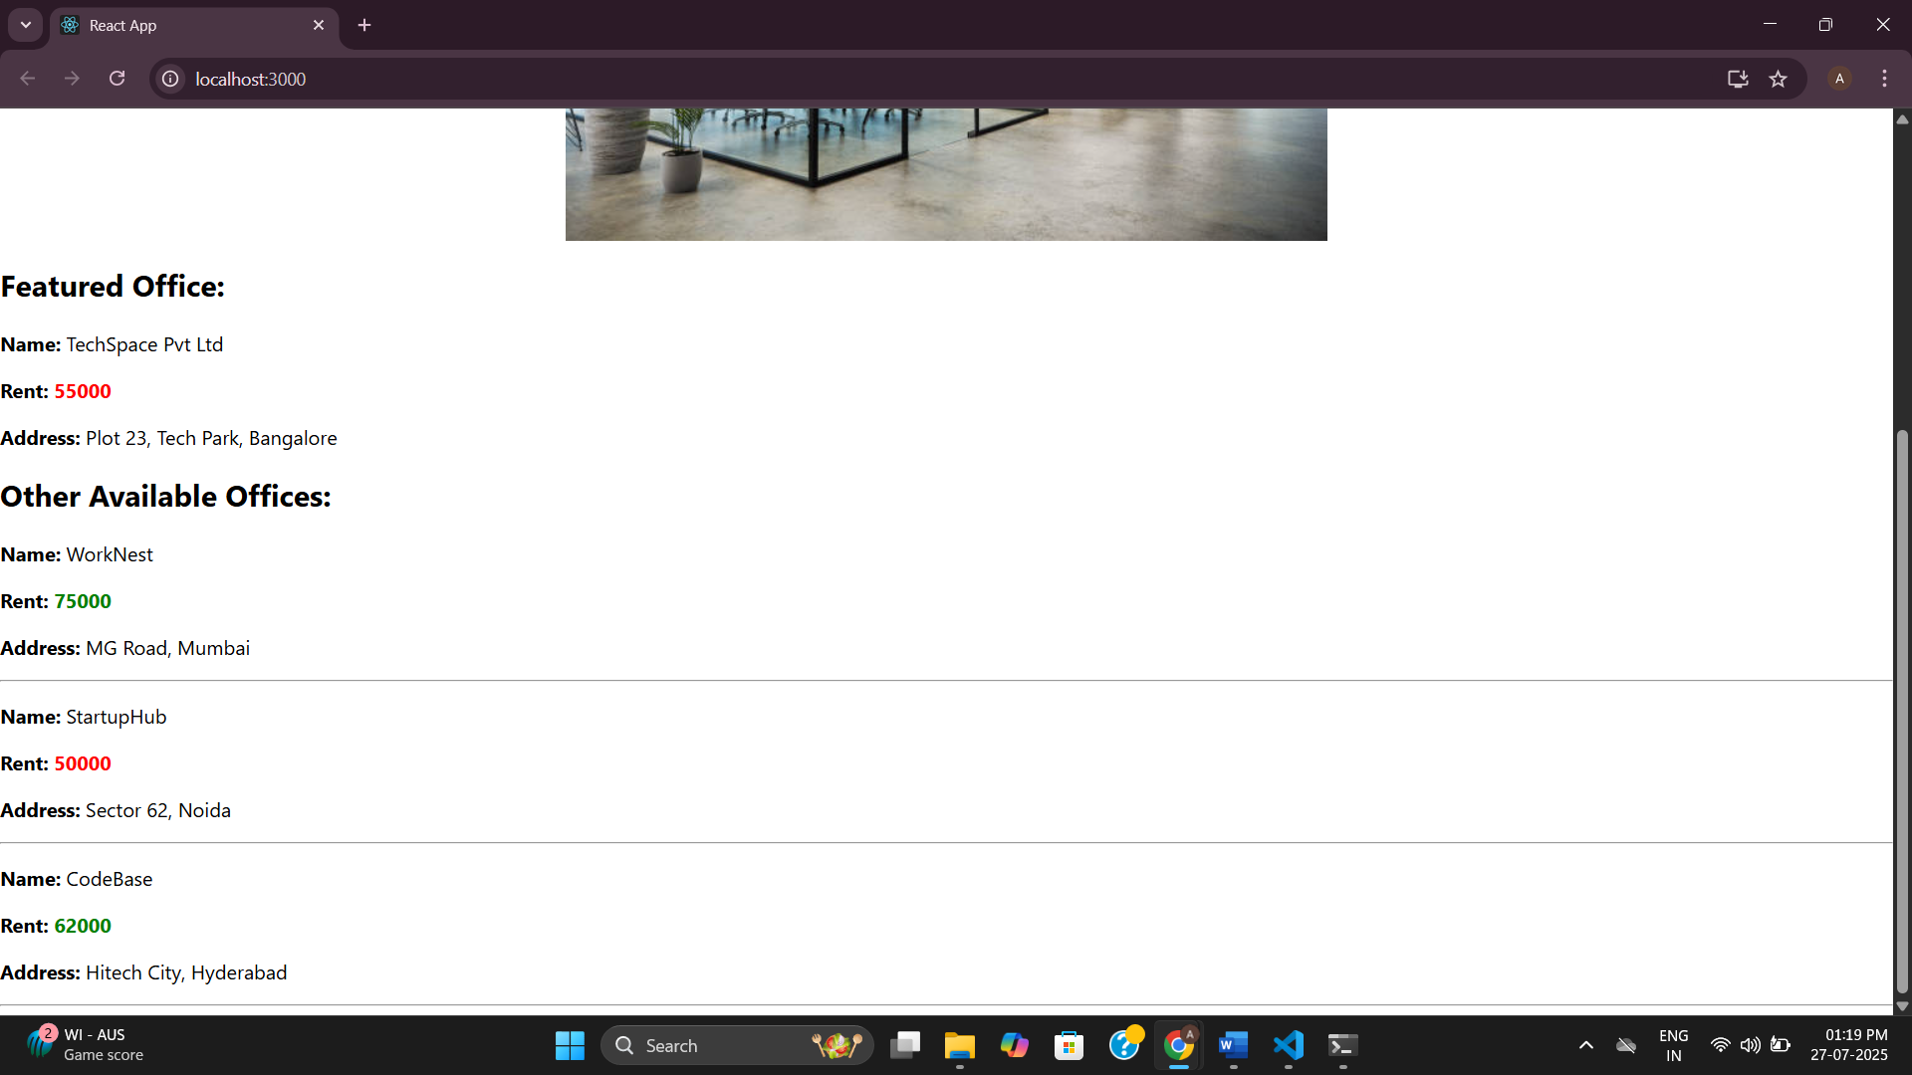

**11.** **React Event Handling Example App**

**App.js**

import React, { useState } from 'react';

import CurrencyConvertor from './CurrencyConvertor';

function App() {

const [count, setCount] = useState(0);

const increment = () => {

setCount(prev => prev + 1);

sayHello();

showMessage();

};

const decrement = () => {

setCount(prev => prev - 1);

};

const sayHello = () => {

alert("Hello!");

};

const showMessage = () => {

console.log("Static Message: You clicked Increment!");

};

const sayWelcome = (msg) => {

alert(msg);

};

const handleSyntheticEvent = (event) => {

alert("I was clicked");

console.log("Synthetic event type:", event.type);

};

return (

<div style={{ padding: '20px' }}>

<h1>React Event Handling Example</h1>

<h2>Counter: {count}</h2>

<button onClick={increment}>Increment</button>

<button onClick={decrement}>Decrement</button>

<br /><br />

<button onClick={() => sayWelcome("Welcome!")}>Say Welcome</button>

<br /><br />

<button onClick={handleSyntheticEvent}>Synthetic Event Button</button>

<br /><br />

<CurrencyConvertor />

</div>

);

}

export default App;

**CurrencyConvertor.js**

import React, { useState } from 'react';

function CurrencyConvertor() {

const [rupees, setRupees] = useState('');

const [euro, setEuro] = useState(null);

const handleSubmit = () => {

const result = (parseFloat(rupees) / 90).toFixed(2);

setEuro(result);

};

return (

<div>

<h2>Currency Converter</h2>

<input

type="number"

placeholder="Enter Rupees"

value={rupees}

onChange={(e) => setRupees(e.target.value)}

/>

<button onClick={handleSubmit}>Convert</button>

{euro && <p>{rupees} INR = {euro} Euro</p>}

</div>

);

}

export default CurrencyConvertor;

**Output:**

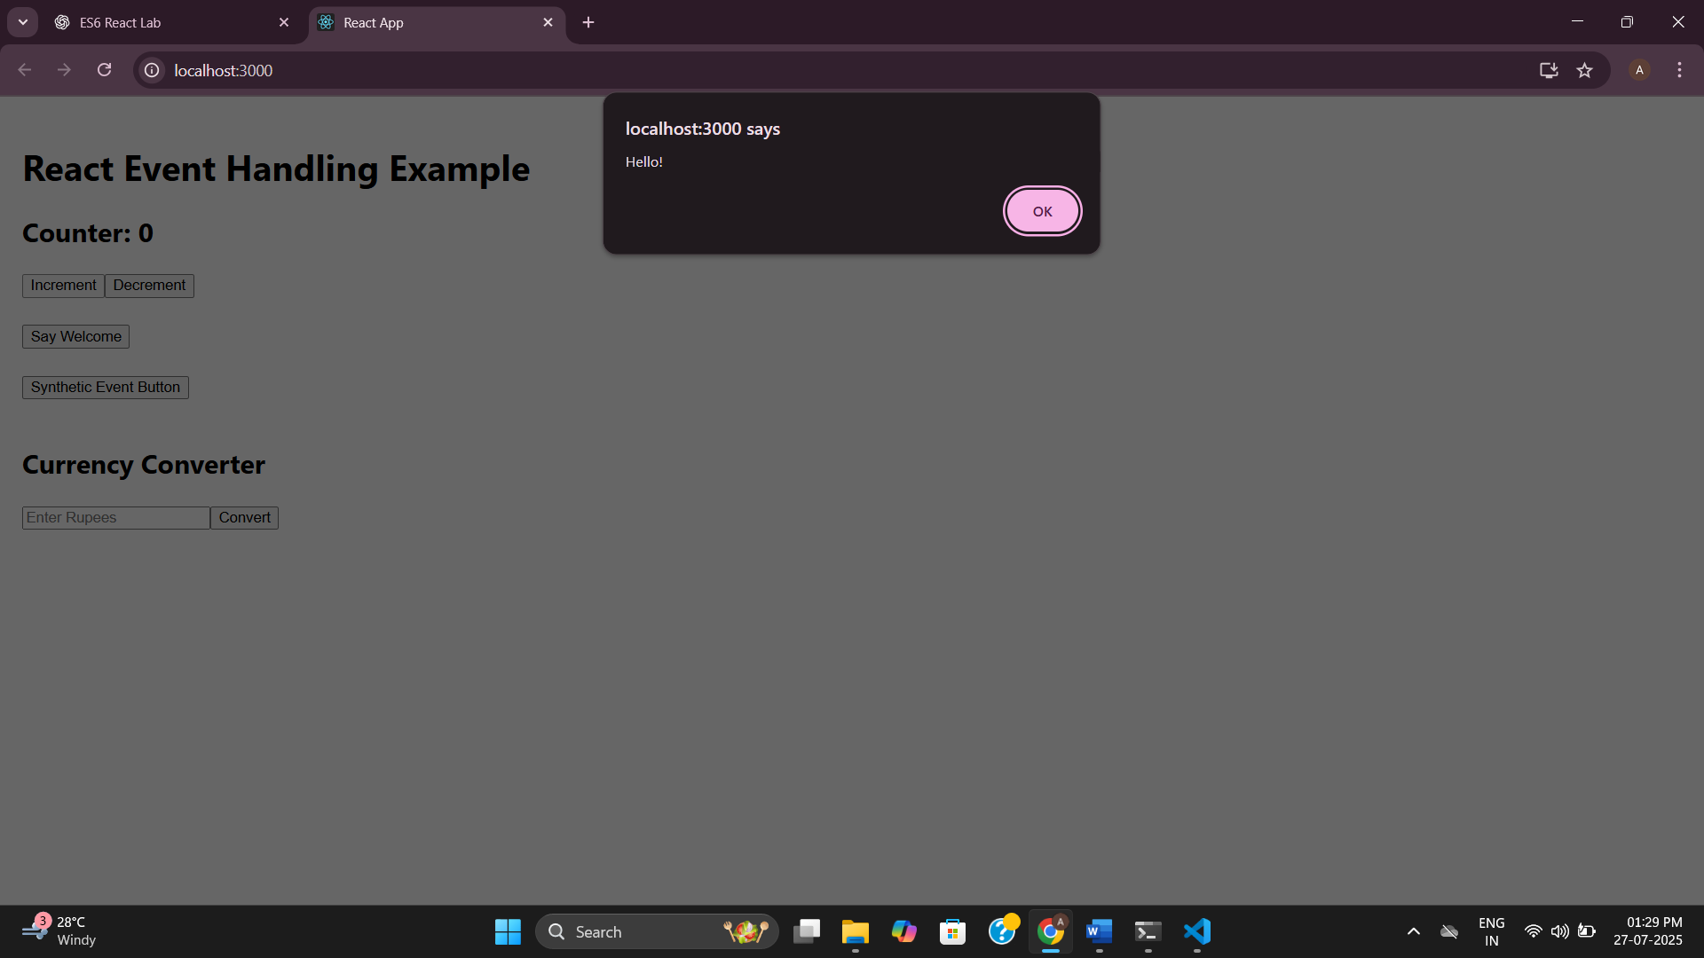

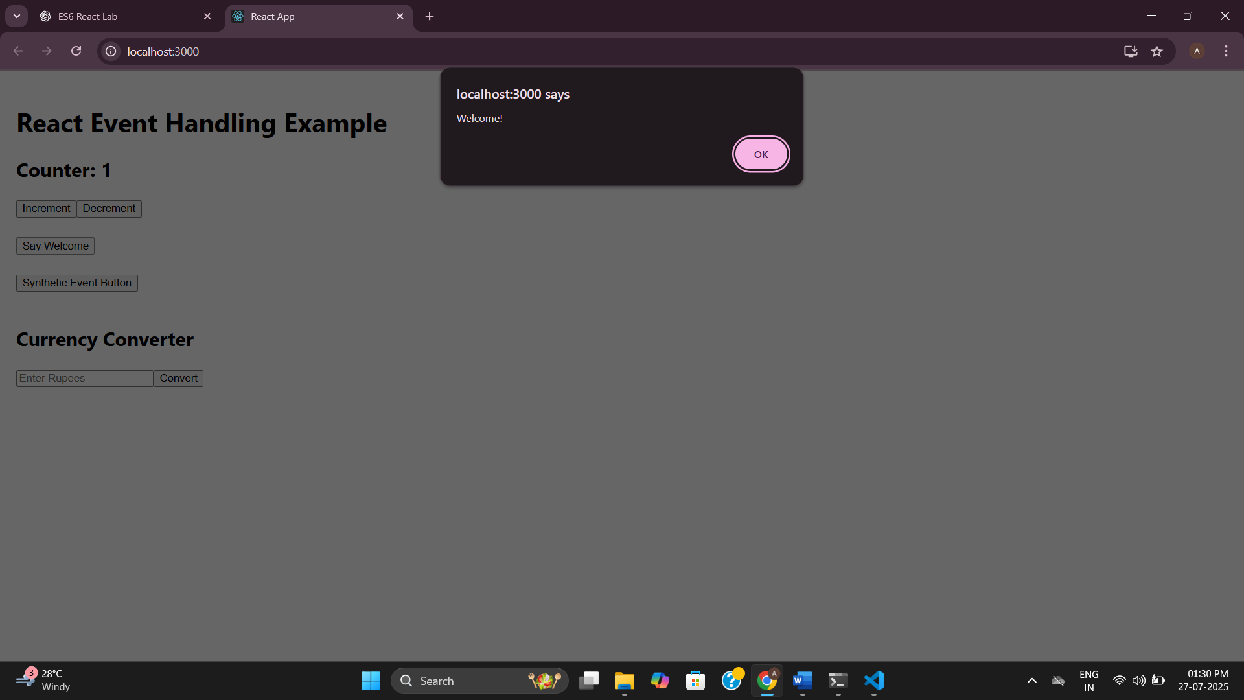

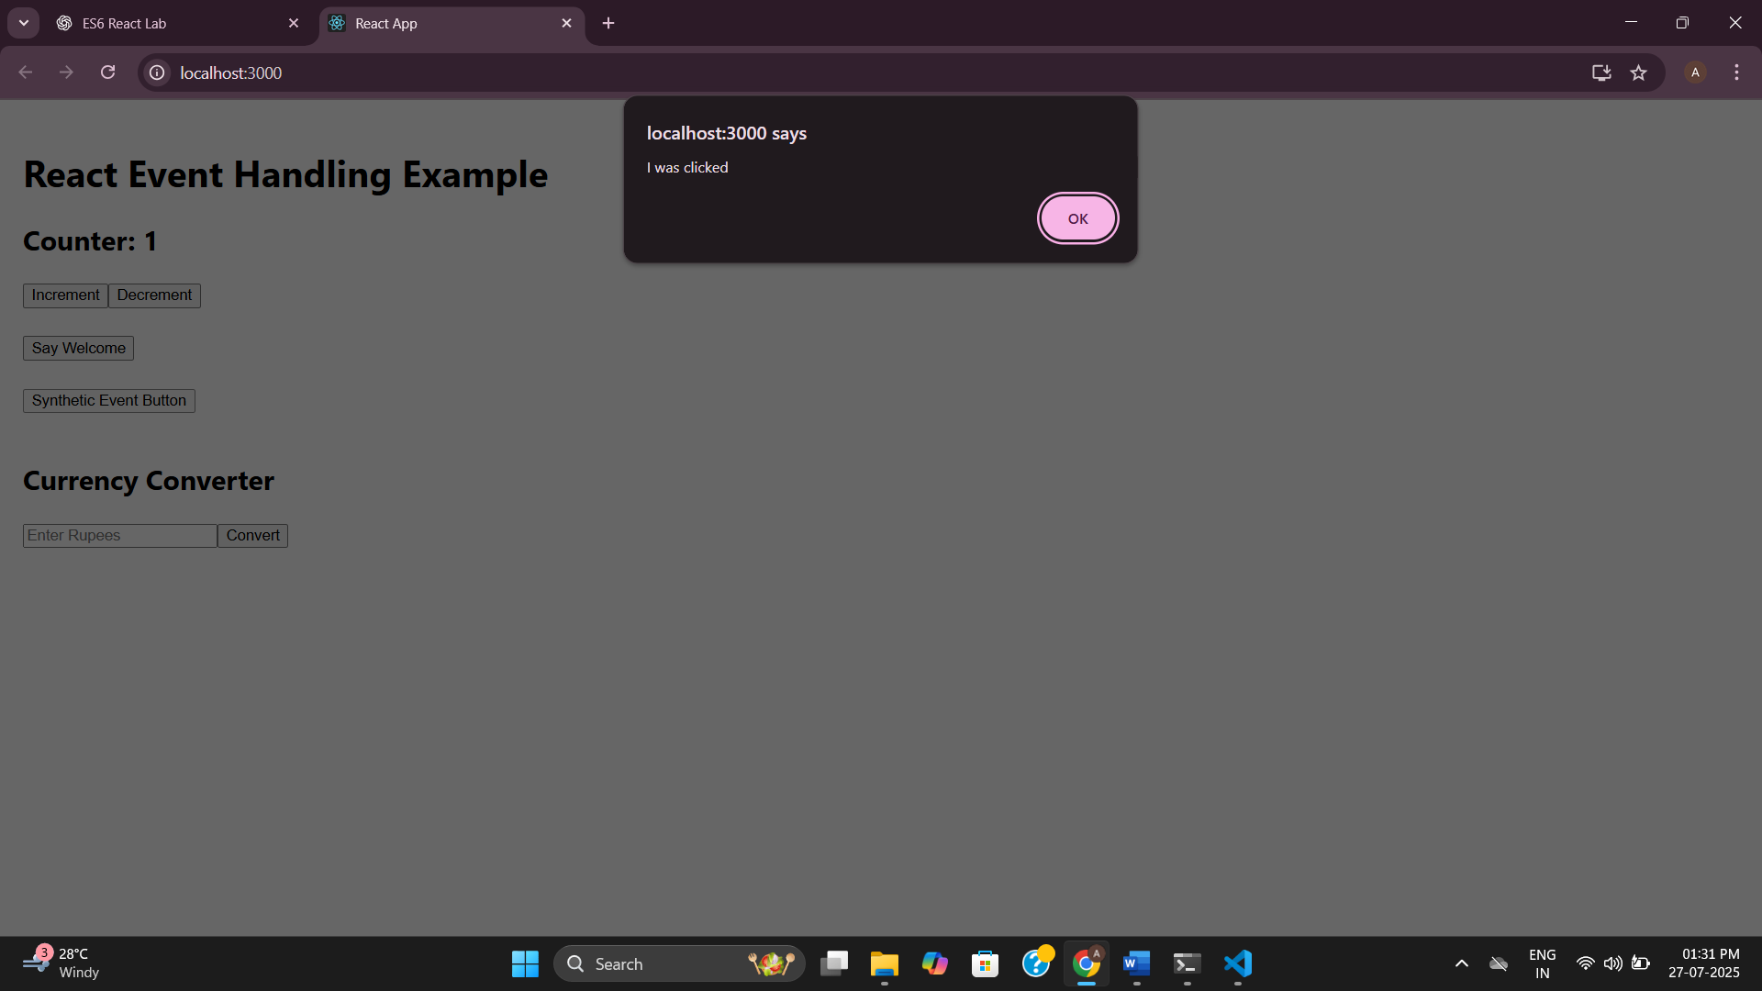

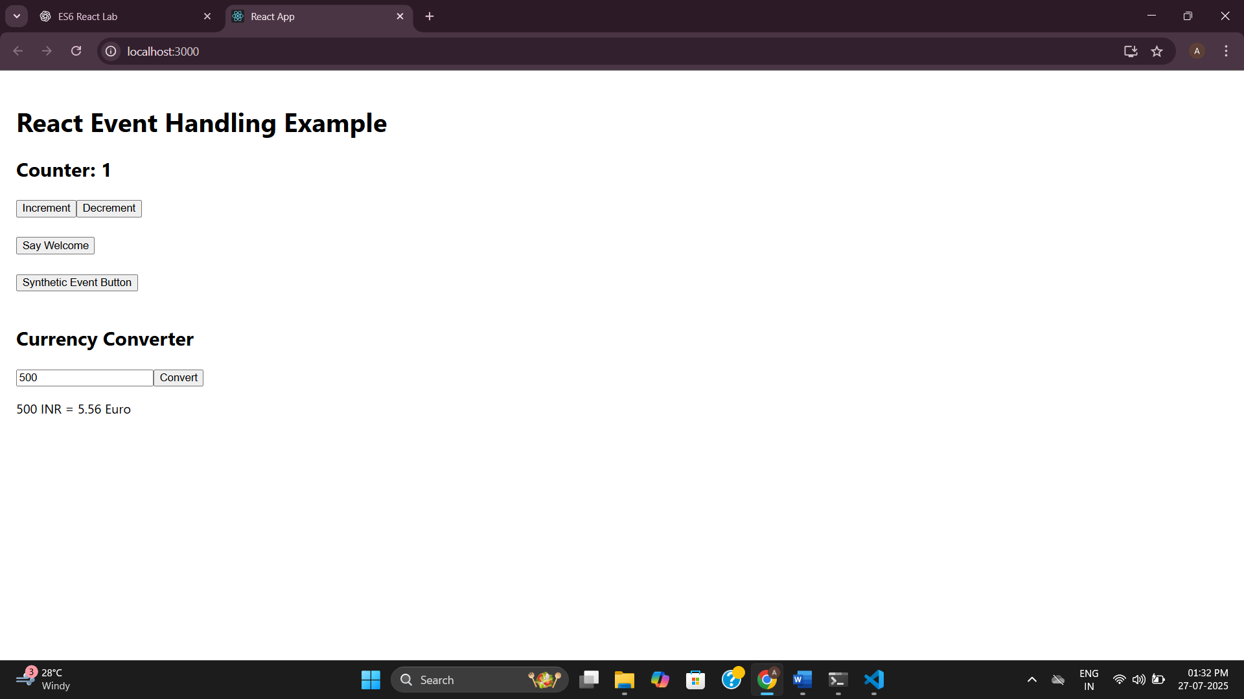

**12.** **TicketBookingApp with Conditional Rendering**

**GuestPage.js**

import React from 'react';

const GuestPage = () => {

return (

<div>

<h2>Welcome Guest!</h2>

<p>Here are the available flights:</p>

<ul>

<li>Flight A123 – Chennai to Delhi</li>

<li>Flight B234 – Mumbai to Bangalore</li>

<li>Flight C345 – Kolkata to Hyderabad</li>

</ul>

</div>

);

};

export default GuestPage;

**UserPage.js**

import React from 'react';

const UserPage = () => {

return (

<div>

<h2>Welcome User!</h2>

<p>You can now book your tickets.</p>

<button>Book Ticket</button>

</div>

);

};

export default UserPage;

**App.js**

// src/App.js

import React, { useState } from 'react';

import GuestPage from './GuestPage';

import UserPage from './UserPage';

function App() {

const [isLoggedIn, setIsLoggedIn] = useState(false);

// Element variable

let page;

if (isLoggedIn) {

page = <UserPage />;

} else {

page = <GuestPage />;

}

return (

<div style={{ padding: '20px' }}>

<h1>Ticket Booking App</h1>

{isLoggedIn ? (

<button onClick={() => setIsLoggedIn(false)}>Logout</button>

) : (

<button onClick={() => setIsLoggedIn(true)}>Login</button>

)}

<hr />

{page}

</div>

);

}

export default App;

**Output:**

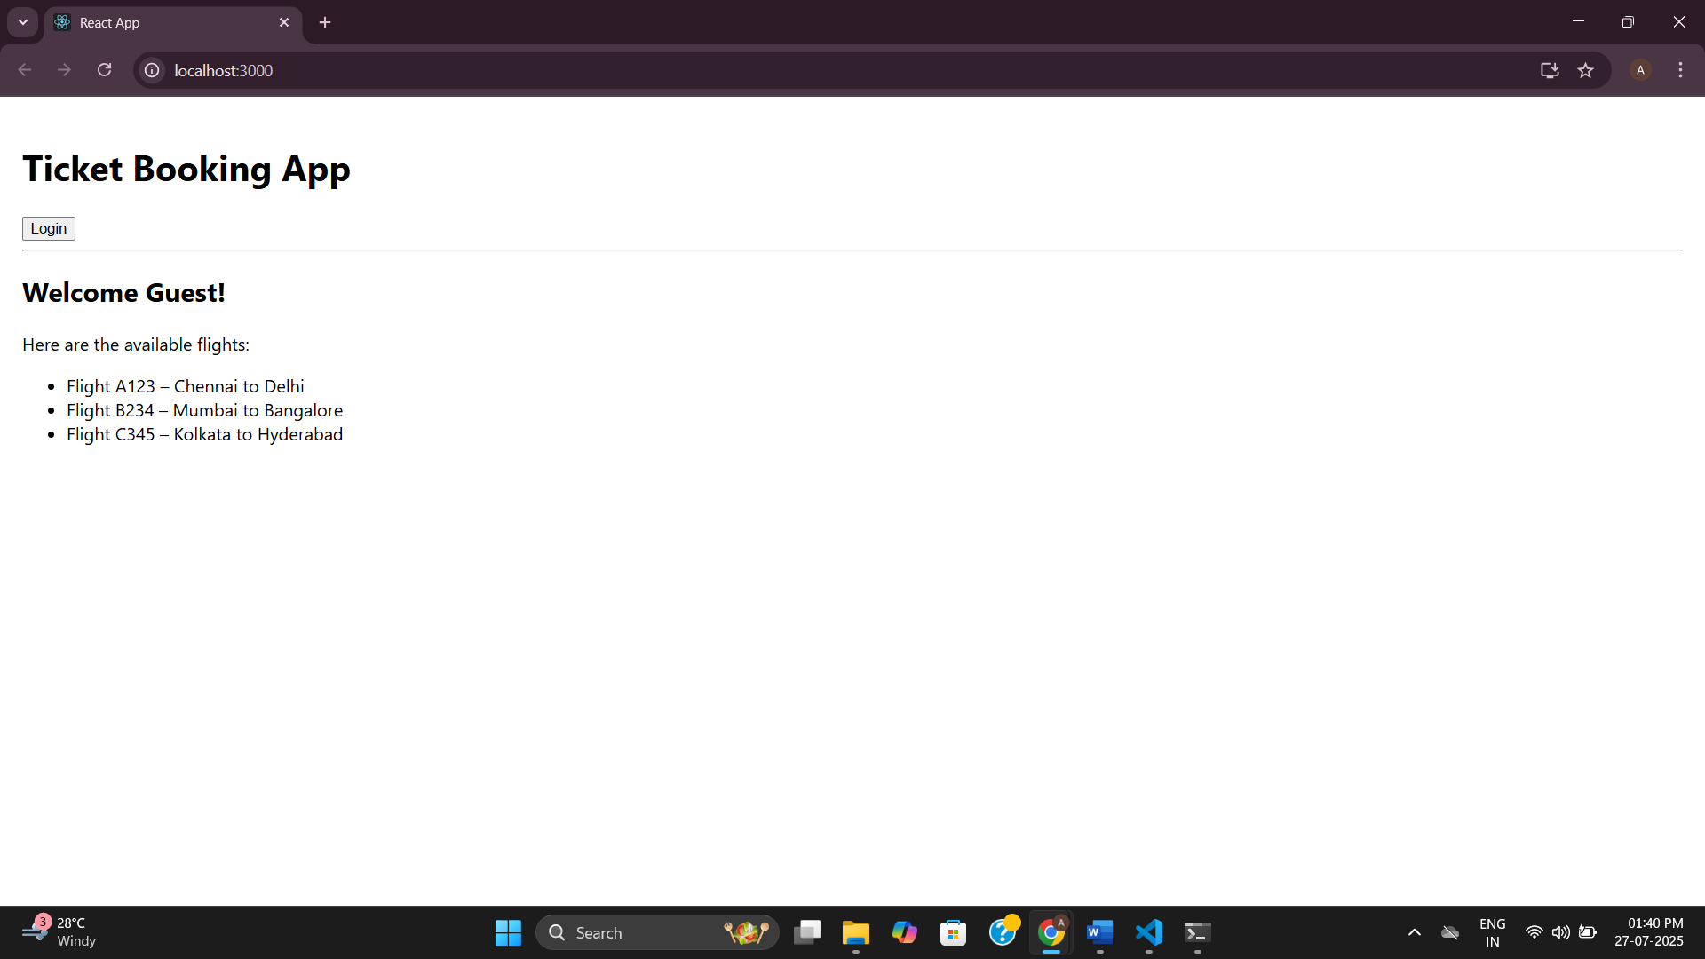

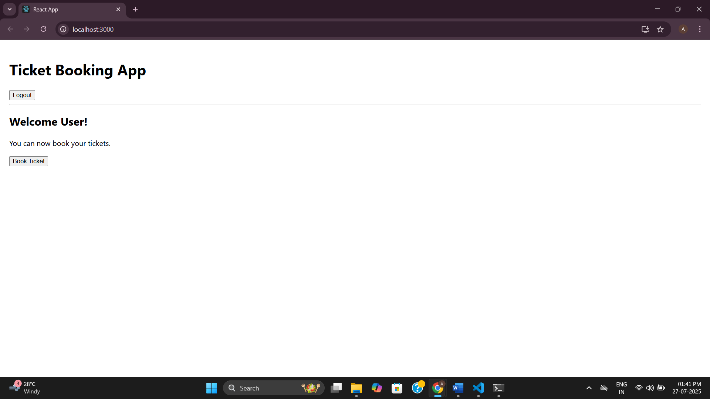

**13.** **BloggerApp with Conditional Rendering**

**BookDetails.js**

import React from 'react';

const BookDetails = () => {

return (

<div>

<h2>📚 Book Details</h2>

<ul>

<li>Title: React Explained</li>

<li>Author: Zac Gordon</li>

<li>Price: ₹599</li>

</ul>

</div>

);

};

export default BookDetails;

**BlogDetails.js**

import React from 'react';

const BlogDetails = () => {

return (

<div>

<h2>📝 Blog Details</h2>

<p>Title: Understanding React Conditional Rendering</p>

<p>Author: Ananth</p>

<p>Date: July 2025</p>

</div>

);

};

export default BlogDetails;

**CourseDetails.js**

import React from 'react';

const CourseDetails = () => {

return (

<div>

<h2>🎓 Course Details</h2>

<ul>

<li>Course: React for Beginners</li>

<li>Instructor: Jane Doe</li>

<li>Duration: 4 Weeks</li>

</ul>

</div>

);

};

export default CourseDetails;

**App.js**

import React, { useState } from 'react';

import BookDetails from './BookDetails';

import BlogDetails from './BlogDetails';

import CourseDetails from './CourseDetails';

function App() {

  const [view, setView] = useState('book');

  // Element variable method

  let content;

  if (view === 'book') {

    content = <BookDetails />;

  } else if (view === 'blog') {

    content = <BlogDetails />;

  } else {

    content = <CourseDetails />;

  }

  return (

    <div style={{ padding: '20px' }}>

      <h1>🧑‍💻 Blogger App</h1>

      {/* Button triggers */}

      <button onClick={() => setView('book')}>Book</button>

      <button onClick={() => setView('blog')}>Blog</button>

      <button onClick={() => setView('course')}>Course</button>

      <hr />

      {/* Way 1: Element variable */}

      {content}

      {/* Way 2: Ternary Operator */}

      {/* {view === 'book' ? <BookDetails /> : view === 'blog' ? <BlogDetails /> : <CourseDetails />} */}

      {/* Way 3: Logical && */}

      {/* {view === 'book' && <BookDetails />}

          {view === 'blog' && <BlogDetails />}

          {view === 'course' && <CourseDetails />} */}

    </div>

  );

}

export default App;

**Output:**

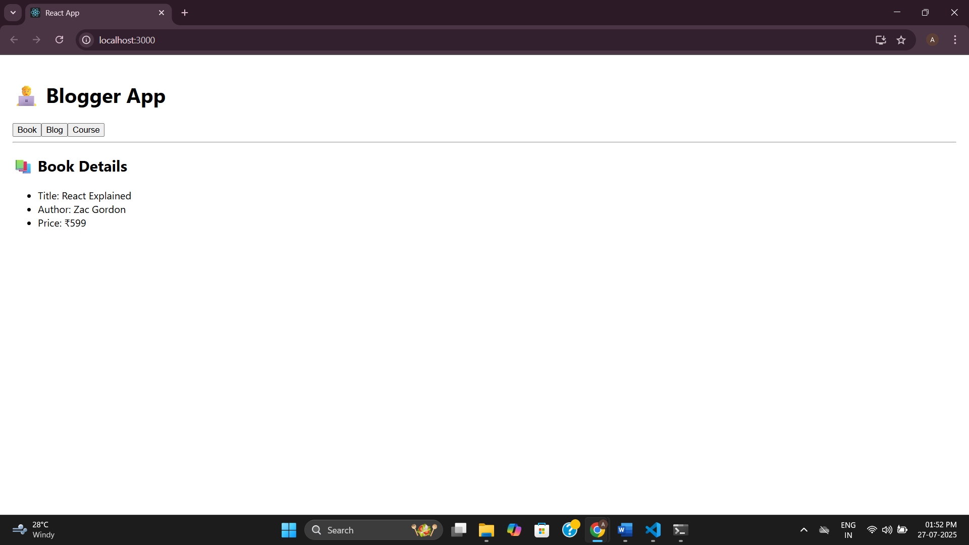

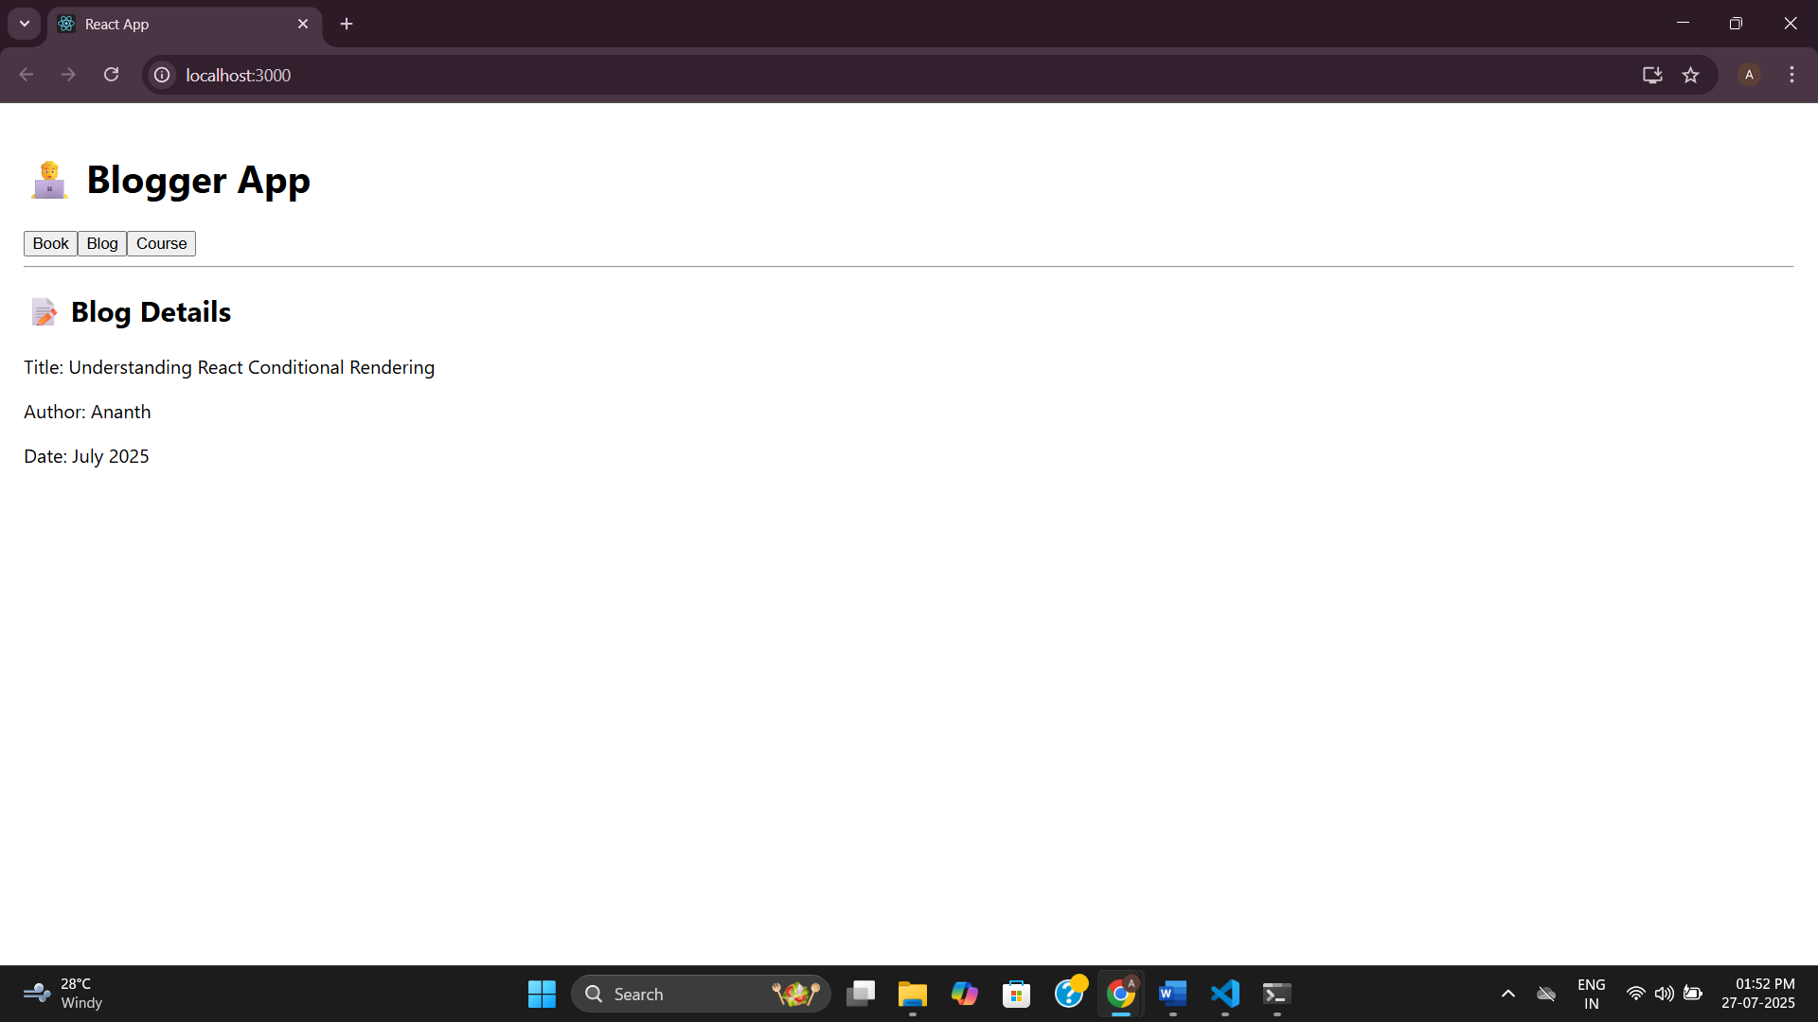

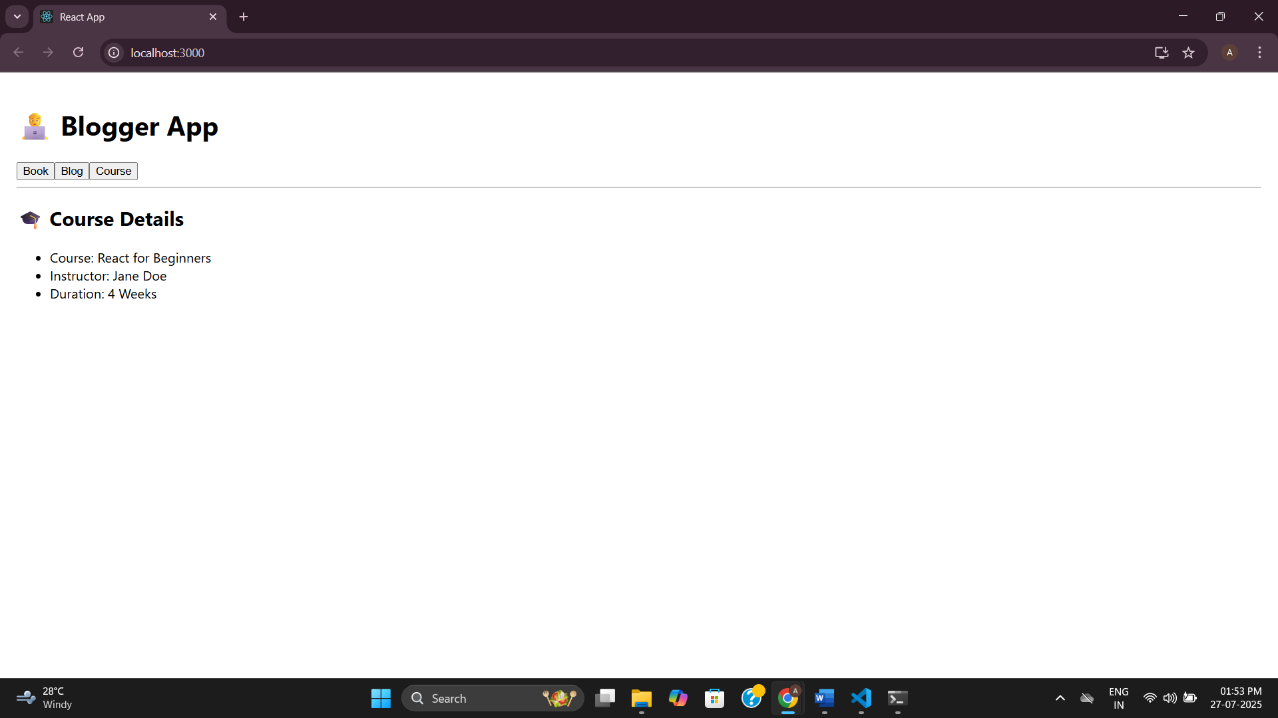

**Additional:**

**14.** **Theme Context Implementation for Employee App**

**ThemeContext.js**

import React from 'react';

const ThemeContext = React.createContext('light');

export default ThemeContext;

**EmployeesList.js**

import React from 'react';

import EmployeeCard from './EmployeeCard';

function EmployeesList() {

  const employees = [

    { id: 1, name: 'Ananth', role: 'Developer' },

    { id: 2, name: 'Roopine', role: 'Designer' },

  ];

  return (

    <div>

      {employees.map((emp) => (

        <EmployeeCard key={emp.id} employee={emp} />

      ))}

    </div>

  );

}

export default EmployeesList;

**EmployeeCard.js**

import React, { useContext } from 'react';

import ThemeContext from './ThemeContext';

function EmployeeCard({ employee }) {

  const theme = useContext(ThemeContext);

  const buttonStyle =

    theme === 'light'

      ? { backgroundColor: '#f0f0f0', color: '#333' }

      : { backgroundColor: '#333', color: '#f0f0f0' };

  return (

    <div style={{ border: '1px solid gray', margin: '10px', padding: '10px' }}>

      <h3>{employee.name}</h3>

      <p>Role: {employee.role}</p>

      <button style={buttonStyle}>View Profile</button>

    </div>

  );

}

export default EmployeeCard;

**App.js**

// src/App.js

import React, { useState } from 'react';

import ThemeContext from './ThemeContext';

import EmployeesList from './EmployeesList';

function App() {

const [theme, setTheme] = useState('light');

return (

<ThemeContext.Provider value={theme}>

<div className="App">

<h1>Employee Management</h1>

<button onClick={() => setTheme(theme === 'light' ? 'dark' : 'light')}>

Toggle Theme

</button>

<EmployeesList />

</div>

</ThemeContext.Provider>

);

}

export default App;

**Output:**

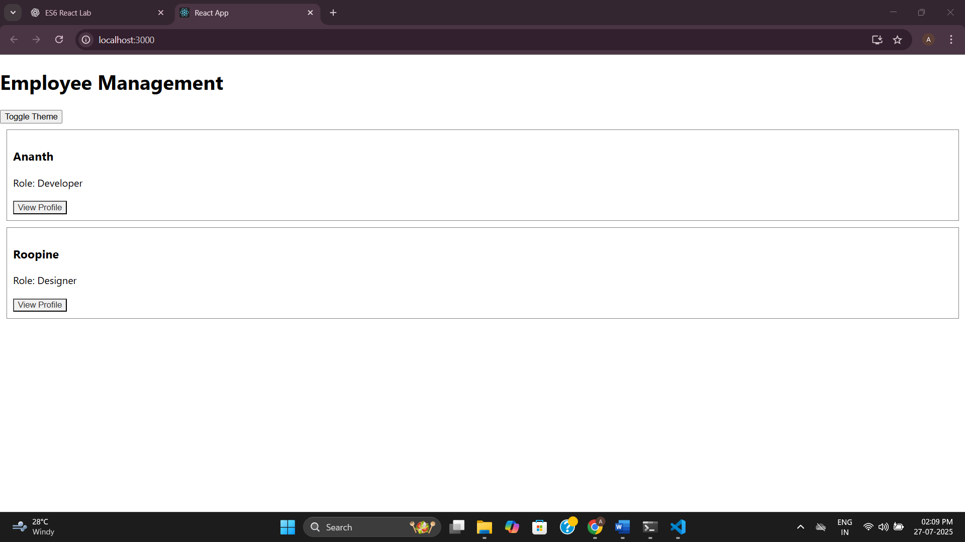

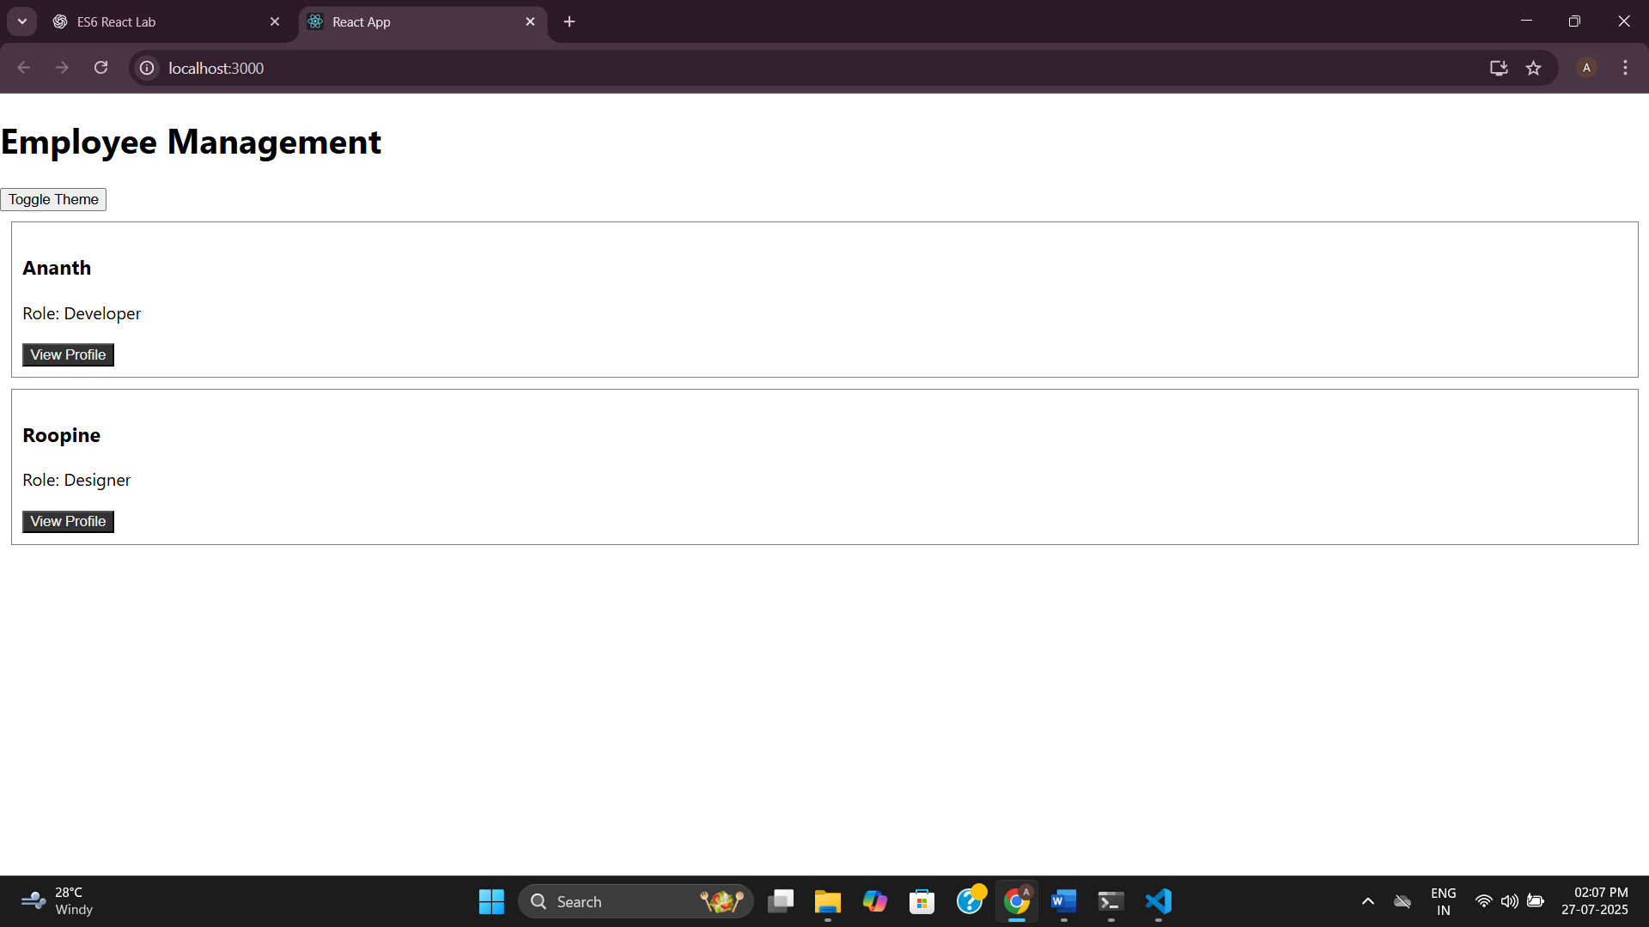

**15.** **TicketRaisingApp using React Forms**

**ComplaintRegister.js**

import React, { useState } from 'react';

function ComplaintRegister() {

const [employeeName, setEmployeeName] = useState('');

const [complaint, setComplaint] = useState('');

const handleSubmit = (e) => {

e.preventDefault(); // prevent page refresh

if (!employeeName || !complaint) {

alert("Please fill in both fields.");

return;

}

const referenceNumber = Math.floor(100000 + Math.random() * 900000);

alert(

`Complaint submitted!\nName: ${employeeName}\nComplaint: ${complaint}\nReference No: REF${referenceNumber}`

);

// Optionally clear form

setEmployeeName('');

setComplaint('');

};

return (

<div style={{ padding: '20px' }}>

<h2>Raise a Complaint</h2>

<form onSubmit={handleSubmit}>

<label>Employee Name:</label><br />

<input

type="text"

value={employeeName}

onChange={(e) => setEmployeeName(e.target.value)}

placeholder="Enter your name"

/><br /><br />

<label>Complaint:</label><br />

<textarea

value={complaint}

onChange={(e) => setComplaint(e.target.value)}

placeholder="Enter your complaint"

rows={4}

cols={40}

/><br /><br />

<button type="submit">Submit</button>

</form>

</div>

);

}

export default ComplaintRegister;

**App.js**

// src/App.js

import React from 'react';

import ComplaintRegister from './ComplaintRegister';

function App() {

return (

<div className="App">

<h1>📝 Ticket Raising App</h1>

<ComplaintRegister />

</div>

);

}

export default App;

**Output:**

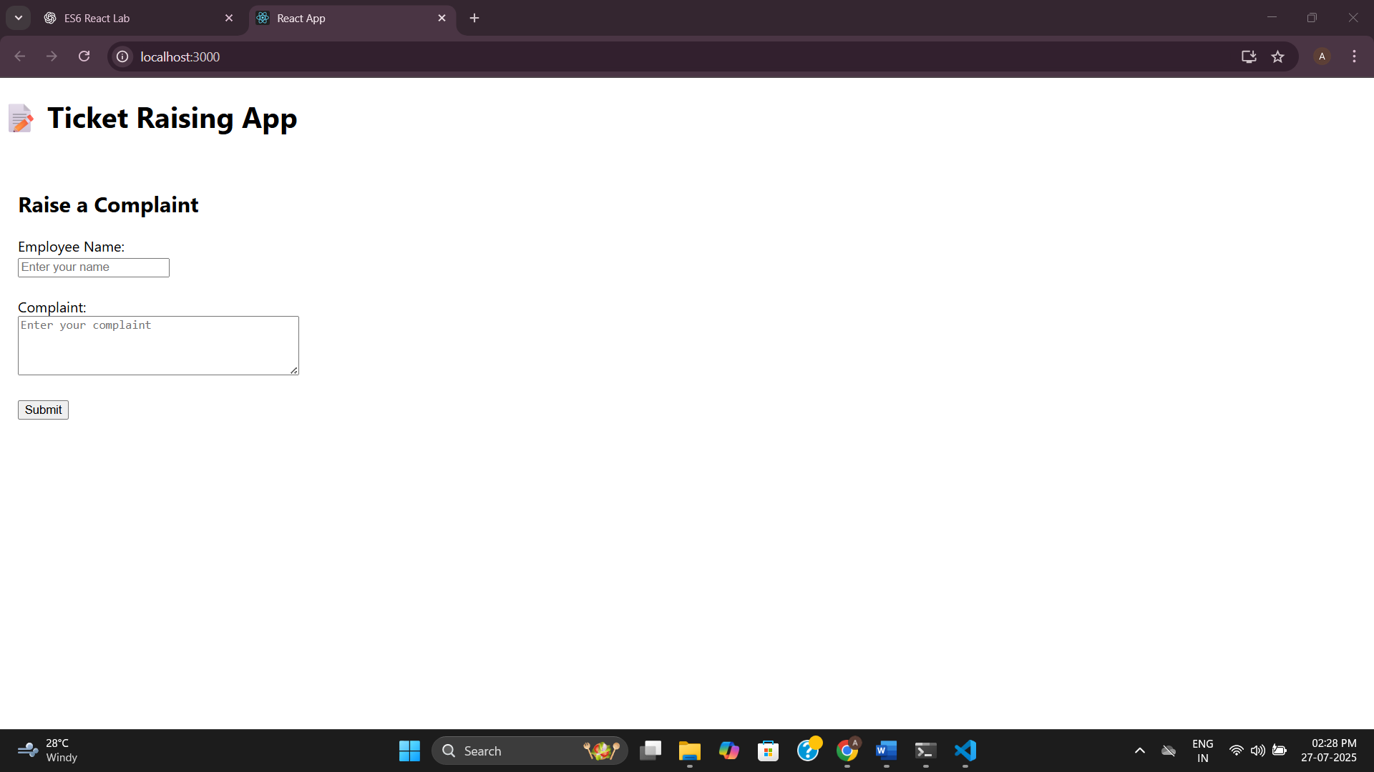

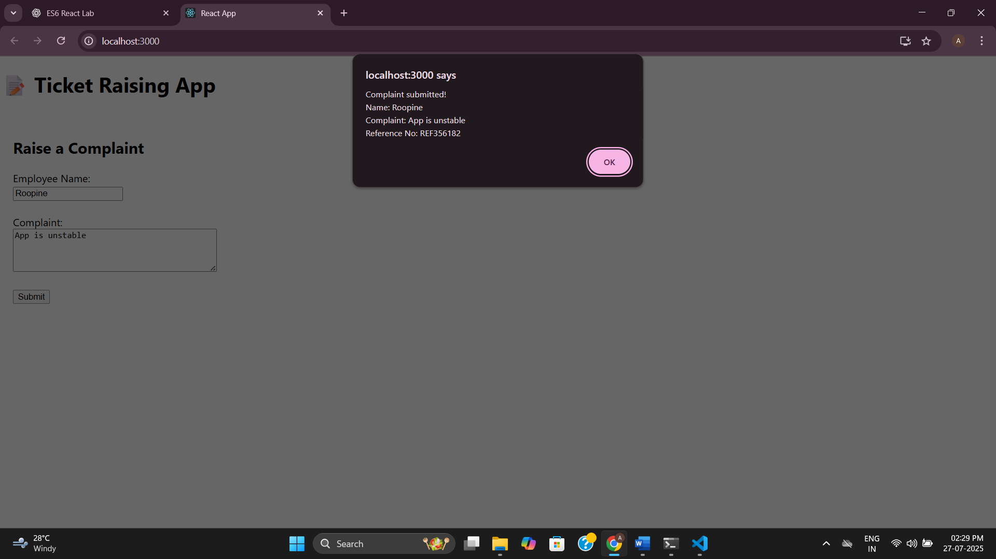

**16.** **MailRegisterApp with Form Validation**

**Register.js**

import React, { useState } from 'react';

function Register() {

const [formData, setFormData] = useState({

name: '',

email: '',

password: '',

});

const [errors, setErrors] = useState({});

const handleChange = (e) => {

const { name, value } = e.target;

setFormData((prevData) => ({

...prevData,

[name]: value,

}));

};

const validate = () => {

let newErrors = {};

if (formData.name.length < 5) {

newErrors.name = 'Name must be at least 5 characters long.';

}

if (!formData.email.includes('@') || !formData.email.includes('.')) {

newErrors.email = 'Email must include "@" and "."';

}

if (formData.password.length < 8) {

newErrors.password = 'Password must be at least 8 characters long.';

}

return newErrors;

};

const handleSubmit = (e) => {

e.preventDefault();

const validationErrors = validate();

if (Object.keys(validationErrors).length === 0) {

alert('Form submitted successfully!');

setFormData({ name: '', email: '', password: '' });

setErrors({});

} else {

setErrors(validationErrors);

}

};

return (

<div style={{ padding: '20px' }}>

<h2>Register Form</h2>

<form onSubmit={handleSubmit}>

<label>Name:</label><br />

<input

type="text"

name="name"

value={formData.name}

onChange={handleChange}

/>

<br />

{errors.name && <span style={{ color: 'red' }}>{errors.name}</span>}

<br /><br />

<label>Email:</label><br />

<input

type="text"

name="email"

value={formData.email}

onChange={handleChange}

/>

<br />

{errors.email && <span style={{ color: 'red' }}>{errors.email}</span>}

<br /><br />

<label>Password:</label><br />

<input

type="password"

name="password"

value={formData.password}

onChange={handleChange}

/>

<br />

{errors.password && <span style={{ color: 'red' }}>{errors.password}</span>}

<br /><br />

<button type="submit">Register</button>

</form>

</div>

);

}

export default Register;

**App.js**

// src/App.js

import React from 'react';

import Register from './Register';

function App() {

return (

<div className="App">

<h1>Mail Register App</h1>

<Register />

</div>

);

}

export default App;

**Output:**

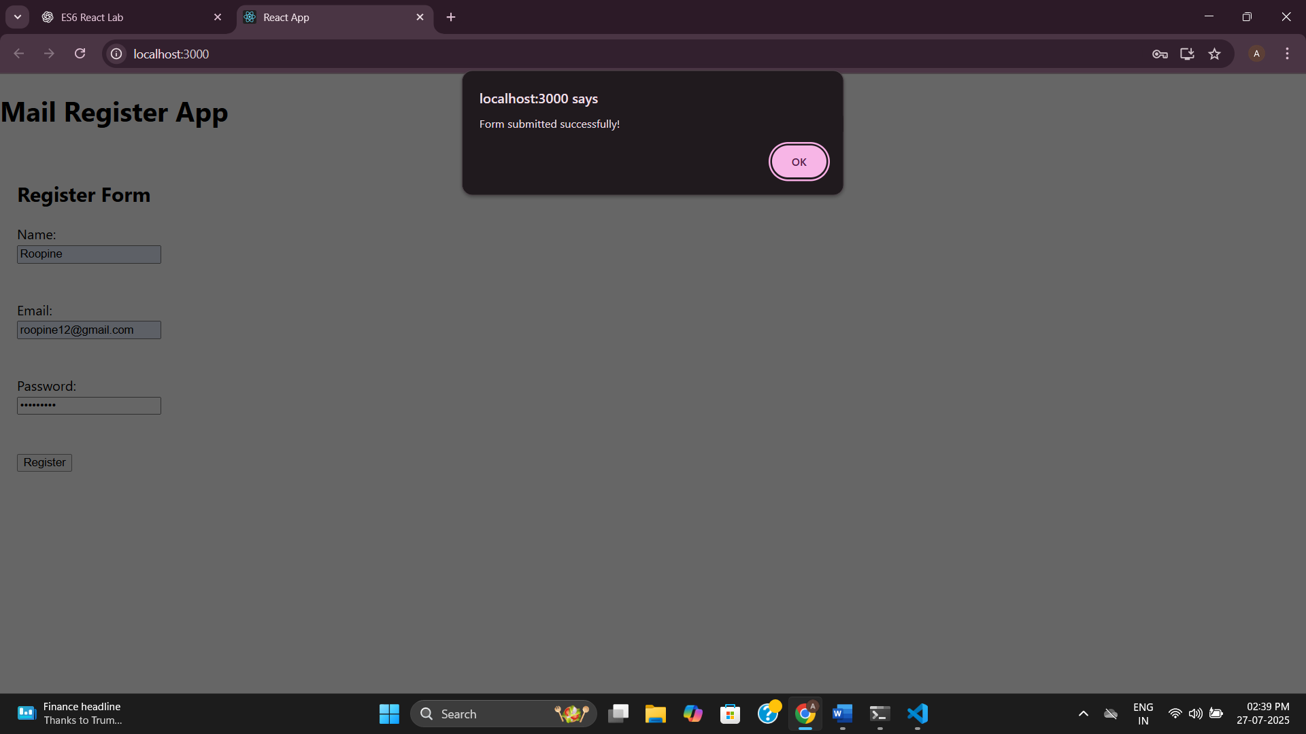

**17.** **Fetch User App – Consuming REST API in React**

**Getuser.js**

// src/Getuser.js

import React, { Component } from 'react';

class Getuser extends Component {

constructor() {

super();

this.state = {

user: null,

loading: true,

};

}

componentDidMount() {

fetch('https://api.randomuser.me/')

.then((response) => response.json())

.then((data) => {

const fetchedUser = data.results[0];

this.setState({

user: {

title: fetchedUser.name.title,

firstName: fetchedUser.name.first,

image: fetchedUser.picture.large,

},

loading: false,

});

})

.catch((error) => {

console.error("Error fetching user:", error);

this.setState({ loading: false });

});

}

render() {

const { user, loading } = this.state;

if (loading) return <p>Loading...</p>;

return (

<div style={{ textAlign: 'center', padding: '20px' }}>

<h2>User Info</h2>

<h3>{user.title} {user.firstName}</h3>

<img src={user.image} alt="User" style={{ borderRadius: '50%' }} />

</div>

);

}

}

export default Getuser;

**App.js**

// src/App.js

import React from 'react';

import Getuser from './Getuser';

function App() {

return (

<div className="App">

<h1>Fetch User App</h1>

<Getuser />

</div>

);

}

export default App;

**Output:**

